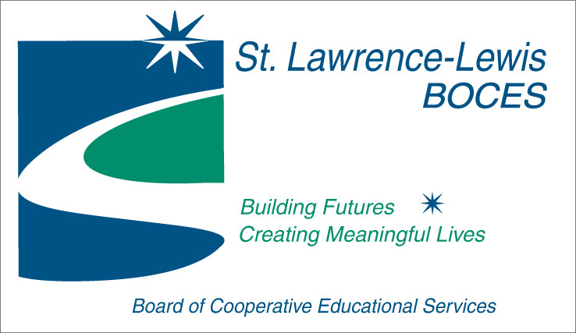Board of Cooperative Educational Services
Sole Supervisory District
St. Lawrence-Lewis Counties
P.O. Box 231, 40 W. Main Street
Canton, New York 13617

Board of Education Meeting Date: January 17, 2019
BOE APPROVED:

The regular meeting of the Board of Cooperative Educational Services of the Sole Supervisory District of St. Lawrence-Lewis Counties was held on Thursday, January 17, 2019 at the Educational Services Center, 40 W. Main Street, Canton, New York. The Board President, Roger Bennett called the meeting to order at 6:00 p.m.

Roll Call:

Present: Roger Bennett, Marjorie McCullough, Michael Davis, Michael Miller, Cindy McLean, William Cartwright and James Young

Via Zoom: James Lattimer (arrived at 6:13 pm)

Absent: Jack Zeh

Others: Thomas Burns, Darin Saiff, Nicole Ashley, Maureen Bouchey, Jane Akins, Rafael Olazagasti, and Renee’ Langtry-Green

All members stood for the Pledge of Allegiance.

No. 2019 – 001  ALL PERSONNEL BOARD ACTION AS FOLLOWS: | Motion made by Young, seconded by McCullough.  Resolved, that the Board of Education of the St. Lawrence-Lewis BOCES, upon the recommendation of District Superintendent Burns, does hereby approve the attached Personnel action: All of the following appointments are conditional, pending clearance from the State Education Department, pursuant to Chapter 180 of the Laws of 2000 of the State of New York.  (In accordance with Board Policy #5150 – Recruitment, Selection, and Appointment of Personnel)  Yeas: All members present  Nays: None
No. 2019 – 002  CONSENT AGENDA ITEMS FOR ACTION | Motion made by Young, seconded by McCullough.  Resolved, that the Board of Education of the St. Lawrence-Lewis BOCES, upon the recommendation of District Superintendent Burns, does hereby approve the following consent agenda items:  Minutes of December 13, 2018 Meeting  (In accordance with Board Policy #1432 – Order of Business at Regular Board Meetings)  Treasurer’s Report for period ending December 31, 2018  (In accordance with Board Policy #1432 – Order of Business at Regular Board Meetings)  - Account Balances  General Fund $ 1,762,144.14  Federal Fund $ 615,465.25  Trust & Agency Fund $ 188.20  Payroll Fund $ 0.00  Capital Renovation Project $ 84,765.57  Capital Equipment Reserve $ 310,608.52  - Current Budget Allocation  - Budget Report  - District Billing  General Fund Budget………………… $ 66,976,521.93  Cooperative Bids  (In accordance with Board Policy #4310 – Purchasing Policy)  - Produce – January & February 2019  - Cafeteria Foods – February - July 2019 for the SLL/JL/FEH/Clinton BOCES Schools  Local Bids  (In accordance with Board Policy #4310 – Purchasing Policy)  - Modular Home #4 located at Seaway CTE Center, Norwood, NY  Sale of Modular Home # 4 located at Seaway CTE Center for the base bid amount of $52,557.99, sales tax $4,204.64 for a total of $56,762.63 to Amie Cota of Madrid, NY. Minimum bid was $52,000.00.  Donation  (In accordance with Board Policy #4230 – Acceptance of Gifts, Grants, and Bequests to BOCES)  - Donation of a 2008 Dodge Avenger to the automotive class for students to learn on at Seaway Technical Center in Norwood valued at $2,000.  Yeas: All members present  Nays: None
Reports: | Thomas R. Burns, District Superintendent  Darin Saiff, Assistant Superintendent for Instruction
Discussion Items: | None
Informational Items: | - Update on Facilities – K. Perretta  - Board of Education Vacancies (R. Bennett, M. Davis, C. McLean, and M. Miller)
Presentations: | None
Other: | Quarterly Claims Report (October – December)
Pass-Around Information: | None
No. 2019 - 003  EXECUTIVE SESSION | Motion made by Davis, seconded by Young.  Resolved, that the Board of Education of the St. Lawrence-Lewis BOCES, upon the recommendation of District Superintendent Burns, does hereby enter into Executive Session for the purposes of collective negotiations pursuant to article 14 of the Civil Service Law and the employment history of a particular person leading to the appointment, employment, promotion, demotion, discipline, suspension, dismissal, or removal of a particular person at 6:37 pm.  Yeas: All members present  Nays: None
 | The Board returned to regular session at 7:36 pm.
No. 2019 - 004  ADJOURNMENT | Motion made by Young, seconded by McCullough to adjourn the meeting at 7:37 p.m.  Yeas: All members present  Nays: None
Maureen A. Bouchey, District Clerk

